**Autonomous Harvesting Robot  
Project Proposal**

Team Tofu  
  
Tan Jin Chun   
Chong Yen Juin  
Chung Chin Leon   
  
Monash University Malaysia  
School of Engineering  
Electrical and Computer System Engineering (ECSE)

Competition Category - Agriculture

# Executive Summary

## General Project Description

*Figure 1 3D Concept of Autonomous Harvesting Robot*

We are pleased to propose our project proposal for the development of an autonomous harvesting robot. The following project aims to create an adept and intelligent robot capable of navigating the farm autonomously, successfully completing the required tasks and demonstrating exceptional performance in plants collection, object, color detection, and precision harvesting tasks. The robot has to traverse the farm autonomously, detect and differentiate between plants and soil and execute an accurate harvest operation to time efficiency, stability, and reliability are essential factors for success.

The major goal of this proposed robot design is to construct an autonomous multi-functional robot that is capable of effectively completing the multifaceted challenges presented. The real-time decision-making system is at the heart of the robot's intelligence. This algorithm is in charge of processing sensory data from multiple sensors, interpreting the environment and executing appropriate actions depending on the task specifications.

The robot navigates the farm automatically without human intervention after receiving instructions via command line interface (CLI), precisely recognizing and discriminating between soil and plant. It is intended to gather harvest efficiently before lifting them off the soil, carrying them to designated regions and performs a precise harvest movement with accuracy. The robot's design has to incorporate collision avoidance as an essential feature. The real-time decision-making algorithm will be designed to process many sensory inputs and dynamically change the robot's direction and activities to prevent collisions with other robots while harvesting. This will necessitate perfect coordination, accurate modelling and the quick execution of complex movements.

The emphasis on robustness and versatility is one of our design's distinctive characteristics. We would build the chassis, gripper arms that could fulfill the requirements of harvesting, ensuring durability and adaptability even in the most challenging conditions. The gripper arms include articulation, allowing them to pivot and adapt to different orientations, hence increasing the robot's action space for efficient plants pickup. Furthermore, we have incorporated advanced color detecting capabilities into the design, fine-tuning the robot's capacity to discern between plant and soil and therefore improving its overall performance.

## Problem Statement

The technical issues presented below in plants detection, collection and harvesting robot design are significant, as they directly impact the performance of the robot.

1. **Autonomous Navigation**
   1. The robot must use sensors and algorithms to navigate the farm with little to no human intervention. It needs to map the environment, avoid obstacles, and reach designated zones accurately.
   2. An inaccurate navigation system can lead to diverged paths, and failed tasks, while staying lost in the farm.
   3. The farm is dynamic and sometimes adversarial, with moving robots. The robot must adapt to these changes in real-time and adjust its navigation strategy accordingly.
   4. Gears in the motor experienced mechanical **wear and degradation** over time, leading to changes in performance in navigation.
   5. Approaches that might fail:
      1. **Dead-Reckoning Only:** Some other alternative approach may involve the use of dead reckoning as the only method for navigation, but it is well-known that this approach is prone to accumulation of errors over time, leading to inaccurate positioning and navigation.
      2. **Lack of Sensor Redundancy:** Relying on a single type of sensor or insufficient sensor redundancy could be a failure point. If a crucial sensor fails, then the navigation reliability is compromised.
2. **Object Detection:**
   1. The robot must be able to use IR sensors for plants, robot obstacle detection within the farm.
   2. Inaccurate plant detection can lead to the robot picking up nothing.
3. **Plant Harvesting Mechanism**
   1. The robot needs a reliable and efficient mechanism to collect plants, then lift them up from the soil. If the collection mechanism is not optimized, it may cause plants to be dropped or fail to pick up plants properly, leading to inefficiencies in task completion.
   2. **Time optimization of Plants Collection Process**
      1. The plants collection mechanism’s efficiency is measured by how much time is needed for the robot to gather plants from the designated collection zone without failure. A time-optimized mechanism can speed up the collection process, allowing the robot to retrieve the necessary plants quickly.
   3. **Conserving Energy and Resources**
      1. Once the plants have been gripped, the servo motor that governs the movement of the mechanical gripper should exert minimal force while maintaining a tight grip to save battery power, which is limited. This energy conservation serves to extend the operating time on a single battery charge.
4. **Color Sensing**
   1. The autonomous robot needs color sensing to distinguish between the plants of different colors and soil to determine the location.
   2. Problems:
      1. **Noise in Color Sensing:** Color sensor readings can be influenced by noise, variability, due to the manufacturing of plants and the degradation of quality in the color sensor's performance. This demands our algorithms to filter out noise and handle variations.
      2. **Multiple Objectives:** Color sensors serve to identify the plants and farm floor’s color, which is a complex challenge.
      3. **Ambient or Adversarial Light Interference:** Ambient lighting conditions within farm or flashing lights by humans, can interfere with color sensing. This demands for algorithms or hardware setup to filter out noise and strong lights.
      4. **Color Sensor Placement**: The effectiveness of the color sensor wanes as distance increases. The optimal range of detection is within 1cm of distance, as recommended by datasheet. Hence, placement and alignment of the color sensor affect its effectiveness. Determining the optimal position that minimizes the impact of shadows or uneven lighting on color detection requires careful consideration.
      5. **Color Calibration**: We need to ensure the color sensor has a correct threshold to interpret colors correctly over time, across different lighting conditions. There is a demand to address variations in sensor performance due to aging.
5. **Robot Construction Constraints**
   1. The robot must be constructed to fit within a reasonably sized square, ensuring it remains compact and manageable for operational purposes.
   2. Additional components purchased must be recorded in detail and total expenditure must not exceed a certain of preset price.
   3. The robot must be structurally sound, such that it will not collapse, breakdown, or topple throughout the harvest. Connecting and attaching components must be done using nuts and bolts without the use of adhesives such as glue, tape, or zip ties.
   4. Power consumption of the robot must be as low as possible. The use of batteries as its power source limits the amount of power that is available, hence the robot must be very energy efficient.

## Aim and Objectives

The aim of this project is to design, construct and validate an autonomous robotic system capable of efficient plant detection, collection, and precision harvesting in a dynamic farm environment. This robot will utilize advanced navigation algorithms, object detection sensors, and an energy-efficient harvesting mechanism to perform its tasks autonomously with minimal human intervention. The system will demonstrate adaptability to real-time environmental changes, robustness in various operational conditions and accuracy in plant collection, all while remaining within a compact and energy-efficient design framework. The project will culminate in a fully functioning prototype that adheres to strict construction constraints and budgetary considerations, paving the way for scalable solutions in precision agriculture technology.

## Methodology (Crucial Aspects of the Design)

### Robot Operation Systems

* Previously, interrupts-based or polling-based autonomous robots were implemented. The weaknesses of such systems lie in their limitations in real-time responsiveness, efficiency, and adaptability to dynamic environments. Relying solely on interrupt-driven actions can lead to slow response. Polling-based systems suffer from excessive timing overhead.
* As such, we implement a pseudo behavior tree-based system using depth-first-search with priority. This approach offers a more structured, and dynamic framework for the robot's decision-making process.
* Depth-first search allows the autonomous robot to explore different action sequences, enabling it to adapt to changing environments, while making optimal decisions to achieve desired outcomes, based on the real-time input from the sensors and its state. The integration of priority ensures that critical tasks are addressed promptly, while maintaining the flexibility to adjust its own action, and the correct child node containing some functions are accessed in the right order.
* Depth-first search with priority creates a tree-like structure which could be visualized, and its behavior easily predicted and imagined.

### Robot Navigation Requirements

* To always determine the position of the robot, DC motors with shaft encoders are used as feedback mechanisms to measure the angular motion of the wheels, subsequently used to compute the displacement of the robot in the farm floor.
* Ultrasonic sensors are placed at the side of the robot to measure the distance between the robot and the walls of the farm. This along with the feedback mechanism from the shaft encoders work together to improve the performance and accuracy of the proposed dead reckoning navigation algorithm.
* While the rules of the competition limit the possibility of collisions, the center of the farm containing all the plants has a possibility of robots knocking into one another. Another use case of the ultrasonic sensor is to sense the relative speed of the opposing robot and initiate an evasion behavior. This is explained more thoroughly in the “System Integration: Obstacle Detection and Collision Avoidance” section.

### Plants Manipulation

* There will be 2 platforms, one on top of another, supported by beams. The upper level houses the rotatable arm that contains a TCS3200 color sensor and unbranded IR sensors to determine the color of the lanes at level 2 and above. This information is crucial to determine what the relevant color plants are valid.
* The bottom of the upper level houses the color sensor to determine the validity of the plants picked up when the gripper grips a plant, and the gripper arm rotates upwards.
* While there are many methods of collecting the plants, a simple horizontal geared double four-bar gripper was used as the collection mechanism to reduce complexity, while maintaining some of the advantages offered by such design. Given that the plants need to be lifted from the soil, this gripper acts as both plants collection and plants storage mechanism, as it lifts the plants up and transport it to the plants drop-off area before the gripper arm rotates back downwards, placing the plants in the designated area.

# Overview of Robot Design

## Technical Drawings

The figures provided exclude the robot's outer casing (protective equipment) for a comprehensive view of its internal electronic and sensory components. The essential electronic constituents are:

* **PSoC Microcontroller**
  + PSoC Microcontroller will be serving as the core of the autonomous robot, it governs the behavior of the robot through the algorithms programmed inside.
* **DC Motors with Shaft Encoders**
  + The inclusion of shaft encoders provides real-time feedback on the rotational position and speed of the motors. This feedback mechanism enables tracking and regulation of motion, allowing the robot to traverse the farm floor accurately.
* **Motor Driver**
  + It offers speed control using the varying voltage, or pulse-width modulation (PWM) signals provided to the driver, hence, the motor’s speed could be adjusted according to the requirements.
  + Motor drivers incorporate protective features such as overcurrent protection, overtemperature protection, and short-circuit protection. These mechanisms safeguard the motor and driver from damages.
  + Motor drivers also convert the control signals from the microcontroller into the higher power levels needed by the motors.
* **Ultrasonic Sensors**
  + In this case, HY-SRF05 ultrasonic module ultrasonic sensors given in the project toolkit are used for farm positioning and collision detection, aiding in collision avoidance and navigation.
* **IR Proximity Sensors**
  + Installed both in front of the robot and its extension arm. These sensors identify plants and robots in proximity.
* **Color Sensors**
  + Color sensors ascertain the color of the plants and soil, thus enabling the robot to effectively interact with the farm elements.
* **Servo Motors**
  + Responsible for manipulation of plants and pivots.
  + Servo motors govern the movement of the gripper arm, facilitating the capture, release, and placement of plants.
* **Battery Holders**
  + To accommodate batteries
* **Voltage Regulation Components**
  + Consisting of buck converters and some other associated circuitry
  + Manage and stabilize voltage levels, enhancing energy utilization efficiency.

Extension Arm

*Figure 2 Front View*

*Figure 3 Rear View*

Ultrasonic sensor

Colour Sensor

*Figure 4 Side View*

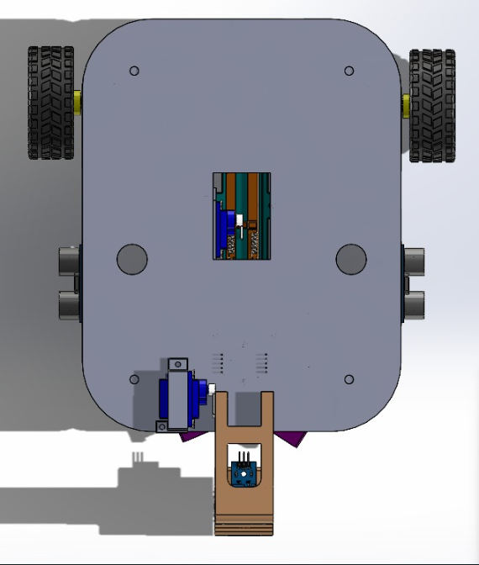

*Figure 5 Top View*

IR Proximity Sensors

Caster Wheels

*Figure 6 Bottom View*

Servo Motors

*Figure 7 Isometric View*

## Operation Systems

A block diagram is shown below to describe the overview of the process below. The flow chart on the left shows the program behavior.

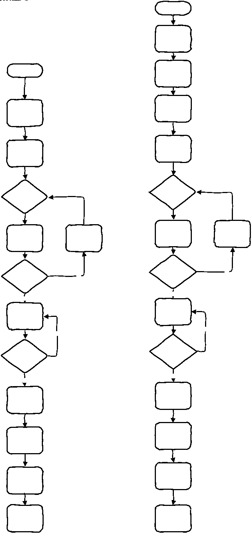

*Figure 8 Block Diagram of Operation Systems*

Through observation of the previous systems designed in the past competitions, we have identified several weaknesses. Most designs used a sequential of tasks with interrupts-driven systems for robot plants harvesting and collecting systems. While using interrupts can offer some advantages, it also comes with certain weaknesses that should be considered:

1. Interrupts may consume processing resources, especially in real-time systems like robotics, precise timing is crucial. If too many interrupts are triggered simultaneously, it may lead to *resource contention*, and impacting the performance.
   1. For example, if an adversarial robot (another similar harvesting robot) is rushing to our robot, while our robot is carrying a plant, should collision avoidance have a priority than plants transportation, and thus override the current task? Many such complicated scenario becomes too complex to solve through manual priority re-ordering by the means of trial-and-error.
   2. Implementing an interrupt-driven systems causes overhead and complexity as managing and coordinating interrupts with other control tasks is challenging, especially if the robot project is a multi-domain problem.
2. Handling interrupts can introduce delays in the robot’s response to events, if the interrupt handling takes longer than expected, then it may lead to missed events, or synchronization problems to the central control system.
3. Interrupt Conflicts will introduce debugging challenges. Debugging interrupt-driven systems is more challenging than a sequential system. As interrupts can occur at any time, identifying the root cause of issues is difficult.
   1. In certain environments, the robot's sensors may be susceptible to external noise or interference, leading to false interrupts and incorrect robot behavior.
   2. Our robotic systems require predictive control due to the requirements of the competition. Actions need to be planned and executed in anticipation of future events. Interrupt-driven systems may not always be well-suited for such predictive control strategies.

We have derived our idea from a game named Gladiabot. Gladiabot is a real-time strategy game where players control a team of robots known as "gladiabots" and compete against other players or AI-controlled others. In Gladiabots, players must program the behavior and actions of the robots using visual programming language and construct a complex behavior tree. The behavior tree would determine the actions of the robot and complete multi-domain missions such as elimination of robot others, resource collection and transportation and surviving. This is similar to the task objectives of this competition.

Due to the complexity of creating behavior tree, we would create a pseudo behavior tree for the dynamic decision-making process of the robot, using depth first search. Depth first search, with self-defined edges and interrupts may mimic a behavior tree. The advantage of behavior tree is its modularity and ease of understanding since the behavior can be practically drawn out with a piece of paper and pen. By sorting the children of every node, we may create a behavior tree with task priorities through depth first search.

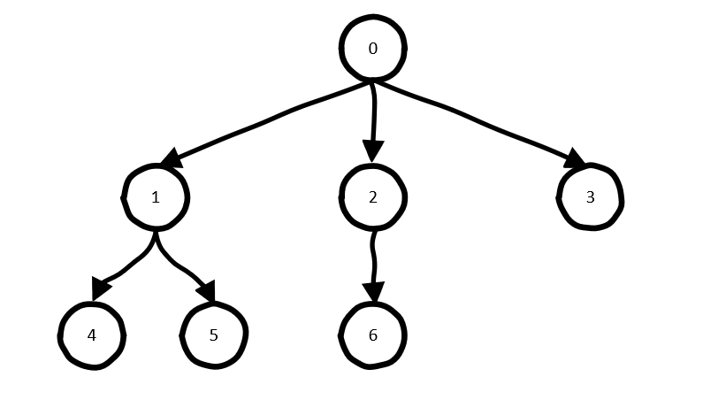

ROOT: AI CONTROL AGENT

*Figure 9 Behavior Tree of Depth-First-Search Algorithm with Priority Sorting*

**Sample output of Depth-First-Search Algorithm with Priority Sorting**:

Visited 0

Function executed for node 0

Visited 1

Function executed for node 1

Visited 4

Function executed for node 4

Visited 5

Function executed for node 5

Visited 2

Function executed for node 2

Visited 6

Function executed for node 6

Visited 3

Function executed for node 3

Depth-first search is a graph traversal algorithm. It starts from a specific, defined node, explores as far as possible along each branch before *backtracking*. It explores deeper into the graph before moving to neighboring nodes. This process continues until all reachable nodes are visited or the desired goal is found. Pairing with the sorting of priority of children nodes within the same level under a parent node, a behavior tree could be created.

Behavior trees offer several advantages superior to polling, or interrupt-only system in robotics:

1. Modularity: Behavior tree breaks down complex behaviors into smaller manageable tasks organized in a tree structure. It is pragmatic as multi-domain robotic problems are often complex. The modularity allows for easy modification of one single function and reusability of behavior nodes.
2. Scalability: Behavior trees are scalable. This advantage is the derivation from its modularity. Since it is simple to modify the tree, it is also simple to expand the system’s behavior as needed.
3. Visualized Debugging: Behavior tree provides a visual representation of the decision-making process of the operation system, making it easy to understand and debug the behavior.

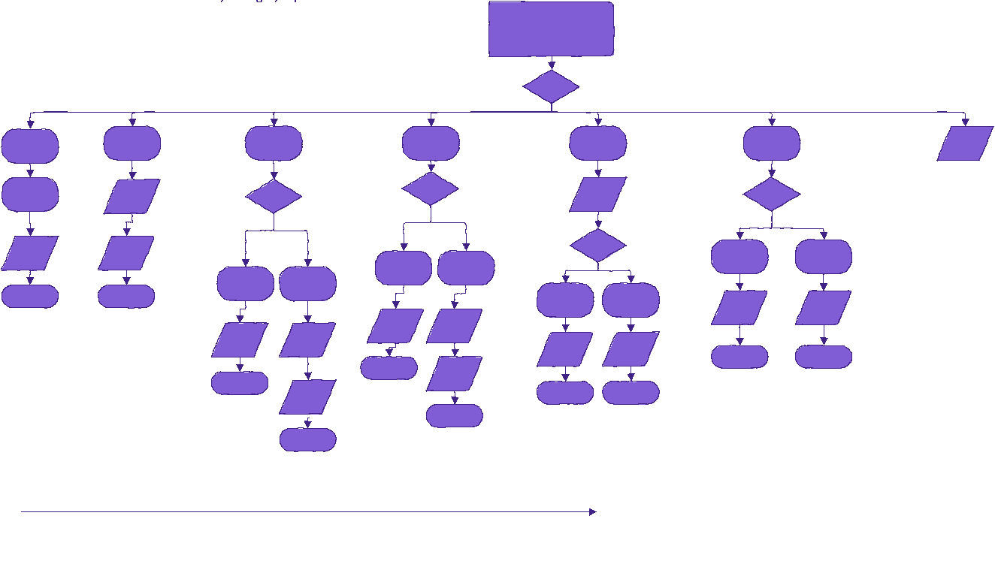

*Figure 10 Behavior Tree of Proposed Algorithm*

# System Integration

## Structure and Locomotion

*Figure 11 Wheel Design of Robot (Bottom View)*

The locomotion system is driven by differential rear-drive mode, with 2 driven wheels positioned at the back of the robot. Each wheel is connected to a Tamiya gearbox, powered by a DC motor with shaft encoder, then, a single L298N motor driver controlled by the PSOC microcontroller would power the two DC motors. A ball caster wheel is placed near the front of the robot for as a support point for stabilization. Besides, most of the heavy structural components are placed at the bottom deck of the robot to improve stability and give higher traction.

This configuration offers certain advantages. The differential rear-drive mode offers improved maneuverability and control compared to other drive configurations. We had considered 3D-printed design of Mecanum wheels, which allows greater maneuverability by enhancing the robot to a holonomic one, but 3D-printed wheels might not provide the same level of traction and grip as purpose-built wheels designed for robotics applications, compared to the wheels 3D printed. The surface texture, material composition of specialized wheels is optimized to provide traction. Hence, we settle for differential rear-drive with ball caster wheel. The inclusion of shaft encoders on the DC motors allows for accurate feedback on the wheels' angular velocity, thus enabling repeatable motion control and dead reckoning.

## Navigation

The farm environment could be partitioned into XY grid, where the initial position of the robot is known before the round begins, manually informed by the humans. The subsequent positions of the robot, $p_{t}$ could be computed using dead-reckoning. Its velocity, $v_{t}$, heading orientation, $h_{t}$, length travelled from the previous record, $l_{t}$ saved in a navigation stack, thereby we can visually retrace the path to analyze the performance and behavior of the robot. The robot may update its position based on its velocity, heading orientation, and the distance traveled from the previous record, which is saved in a navigation stack. This allows for visual retracing of the robot's path, enabling performance and behavior analysis.

The drifting problem of the dead-reckoning technique is well known. Dead reckoning relies on incremental measurements and calculations, leading to cumulative errors that can cause the estimated position to deviate from the actual position over time. Therefore, we need to use some creative techniques to realign and readjust the robot internal navigation state variables. These techniques could include sensor fusion methods, or using *external landmarks* as reference points to correct the estimated position.

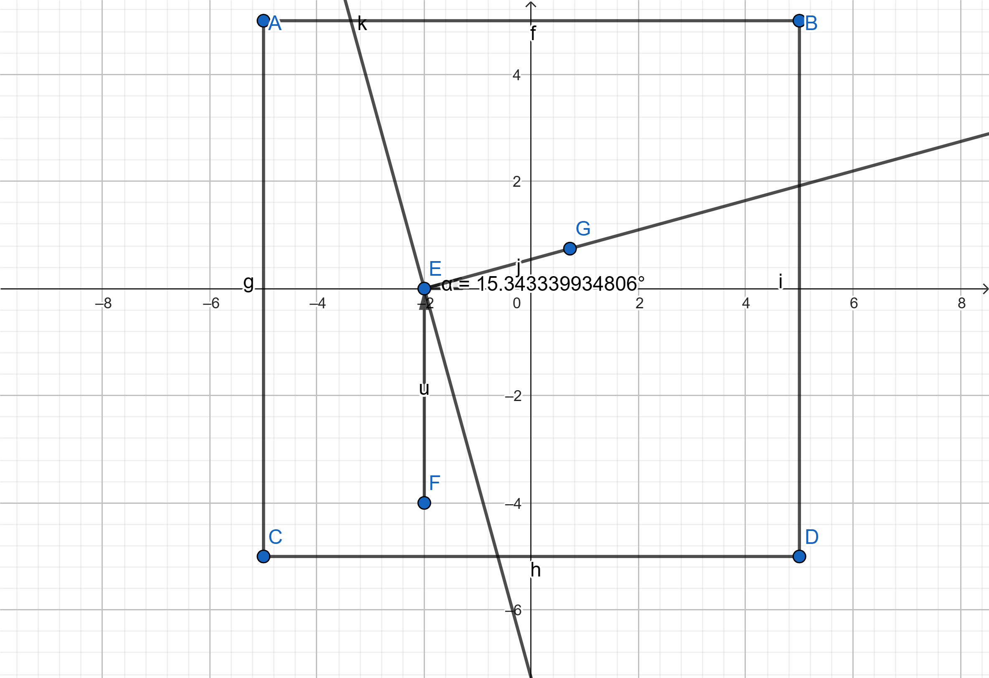

*Figure 12 Mapped Area Environment*

Since the position could be updated, then, if ultrasonic distance sensor is placed at the side of the robots, then using the information of the robot distance to the walls of the farm, the position of the robots can be calibrated by several constraints.

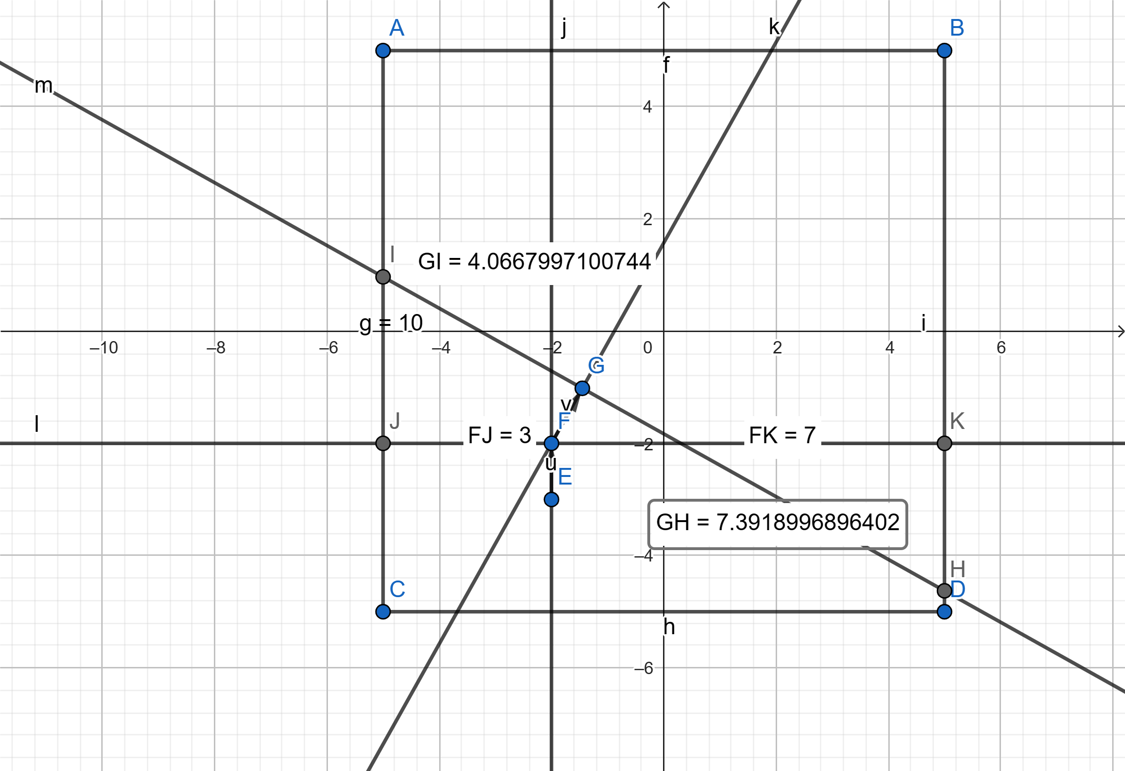

*Figure 13 Updating Position of Robot Using Ultrasonic Sensors to Determine Distance*

Denote the robot’s position at time $t$ as $(x_{t},y_{t})$ where $x_{t}$ is the robot's position along the X-axis and $y_{t}$ is its position along the Y-axis. We will also assume that the robot's heading orientation at time t is given by $θ_{t}$. Let $d_{left_{t}}$ and $d_{right_{t}}$ be the distances measured by the left and right ultrasonic sensors, respectively, at time $t$. The constraints are:

1. Calibration Equation for X-axis:
$$x_{t} = x_{t} - d_{right_{t}} * cos(θ_{t}) + d_{left_{t}} * cos(θ_{t})$$

2. Calibration Equation for Y-axis:

$$y_{t} = y_{t} - d_{right_{t}} * sin(θ_{t}) + d_{left_{t}} * sin(θ_{t})$$

Interestingly, if $90°$ angle motion is desired, then we could implement the ultrasonic distance sensors such that $d_{right_{t}}=d_{left_{t}}$ at most of the times, as the motions are parallel to the wall.

These constraints help to correct the estimated position of the robot based on the information obtained from the ultrasonic sensors. By applying these constraints iteratively, the dead reckoning system can be enhanced to provide a more accurate and reliable representation of the robot's position within the XY grid of the farm.

Dead reckoning for a two-wheel rear-drive robot with differentially driven wheels can be expressed using the following equations:

Let $ω_{r}$ be the angular speed of the right wheel and $ω_{l}$ be the angular speed of the left wheel. **Wheel speeds** can be calculated using the shaft encoder readings for each wheel.

$$ω_{r} = (\frac{Encoder Count Right Wheel}{Counts per Revolution}) * (\frac{2π}{Time Elapsed})$$

$$ω_{l} = (\frac{Encoder Count Left Wheel}{Counts per Revolution}) * (\frac{2π}{Time Elapsed})$$

The **linear velocity** (V) and **angular velocity** (ω) of the robot can be determined based on the wheel speeds.

$$V =\frac{Radius of Wheel * \left(ω_{r} + ω_{l}\right)}{2} ω=\frac{Radius between Wheels * \left(ω_{r} - ω_{l}\right)}{Distance between Wheels}$$

Using the calculated linear and angular velocities, the **robot's position** can be updated over time.

$$∆x=Vcos\left(θ\right)*time elapsed∆y=Vsin\left(θ\right)*time elapsed∆θ=ω*time elapsed$$

Finally, the **robot's position** (X, Y) and **heading orientation** (θ) can be updated,

$$x_{t+1}=x_{t}+∆x$$

$$y_{t+1}=y_{t}+∆y$$

$$∆θ_{t+1}=θ_{t}+∆θ$$

## Obstacle Detection and Collision Avoidance

*Figure 14 IR Sensors and Ultrasonic Distance Sensors*

The farm's size compared to the competing robots reduces the likelihood of head-on collisions with robots, except in the middle region where the plants are located. To detect obstacles and avoid collisions, we utilize IR sensors and HY-SRF05 ultrasonic distance sensors.

It is essential to understand the constraints of depending solely on those pre-programmed maneuvers triggered by an interrupt. A possible cause for worry is the lack of adaptation to unforeseen situations or dynamic changes in the environment. Because the robot's behavior is predetermined, it may be unable to effectively handle complicated situations, resulting in inferior performance in certain demanding settings.

Instead of relying solely on pre-programmed maneuvers triggered by an interrupt, we propose a more dynamic approach based on *relative speed*. If the other's robot approaches at a speed double our robot's speed, an evading maneuver will be initiated. After the evasion, the robot will use its sensors to realign itself with the farm walls, ensuring efficient navigation.

## Plant Color Detection

*Figure 15 Armature with Color Sensor and IR sensor*

In order to streamline the task execution processes and improve the task efficiency (saving time), we decided to take a modular approach by separating the plant’s physical presence detection and color detection modules. When the robot encounters a plant in front of the mechanical gripper, the gripper would grip the plants with IR sensor at the bottom of the deck having a change in electrical signal, then lifting the plants up for color detection at the top. This strategic placement of the color sensor at the top would mitigate potential interference from ambient light, or any adversarial strategies that others may employ, such as shining strong light on our robot.

Our color detection system relies on the TCS3200 programmable color sensor, equipped with 4 white LEDs, which illuminate the plants’ surface. By detecting the reflected colors at specific wavelengths, the sensor achieves color detection. The optimal operating range of this sensor is around 1cm, placing the color sensor too far from the plants would compromise the accuracy of the output, leading to misclassification of the plants’ color. Hence, we positioned the color sensor at an appropriate distance to ensure reliable color detection and facilitate precise decision-making during the competition.

## Plant Color Detection

*Figure 16 Side View of Armature with Color Sensor and IR Sensor*

Color detection is implemented through the TCS3200 color sensor, which is situated at the end of the extensible robotic arm. While the arm is in its idle state, it remains rested on top of the robot. However, once the plants are gripped and lifted, the arm is lowered using the motor, and the color sensor faces groundward, in close proximity to the farm floor, protected by a cover to avoid interference from ambient light.

To address the inherent noisiness of the color sensor readings, we will use a median filter programmatically to filter out the noise. The median filter is effective in removing rapid, instantaneous changes in the electrical signal. With the color sensor facing the ground, it provides feedback to the PSoC microcontroller, updating the robot's location information based on the color-coded regions of the farm. Furthermore, the color sensor identifies the plant leaves, enabling the robot to determine when and where to take action.

## Gripping

During the planning and design phase, we evaluated various gripping mechanisms, recognizing the critical importance of the solution’s robustness for this task as it will be frequently encountered.

*Figure 17 Retractable Armature with Color and IR Sensors*

To solve problem 2, we have decided on a combination of IR sensors and color sensor. The color sensor will be lowered to detect the colors of the farm floor and the IR sensors would detect the robots in vicinity.

## Wireless Communication Bluetooth

The autonomous robot’s communication system will be facilitated through Bluetooth (Bluetooth Serial Transceiver HC-05), interfacing with the UART. To initiate communication, the host would send “**Are you ready?!**”to the robot, and to which the functioning robot would respond with “**Ready**” to indicate its preparedness for the next instruction.

Upon receiving the task details, the robot will acknowledge the receipt by sending the text “**Received**” to the host, and waits for the text “**Start!**” from the host, signaling the start.

# Plants Handling Strategy

**Geared double four-bar gripper**

We decided that a gripper base link would be incorporated into the outermost link in the arm design for a larger action space for effective mechanical gripper. A servo (SG90 plastic gear servo) is the ideal actuator for our gripper due to being lightweight yet powerful enough, and its ease of control. We also decided we wanted to use a simple mechanism for the gripper.

Hence, this mechanical arm grip with geared double four bar is proposed. The gearing system ensures synchronized gripping and releasing actions. The synchronization enhances the stability and control of the gripper during the manipulation of objects. The geared double four-bar mechanism allows adjustment of the mechanical advantage between the servo and the gripper. We will be able to fine-tune the gripping force. It is also relatively simple to design, making it easy to assemble and maintain, while reducing the chances of failures. Also, rubber bumpers, sponges with high coefficient of friction may be added to prevent slipping of plants. The geared double four-bar design facilitates smooth, consistent, and repeatable gripper movements, minimizing jerks that could disrupt the gripping process.

*Figure 18 Overall Design Robot*

# Proposed Project Budget

The table below shows the proposed project budget. The project budget will enable the procurement of high-quality materials and components, ensuring the robot's reliability, durability, and optimal performance throughout the competition. We have constraint the budget to below RM320.

*Table I: Project Budget for Autonomous Robot*

|  |  |  |  |  |  |
| --- | --- | --- | --- | --- | --- |
| **Equipment No.** | **Item Name** | **Quantity** | **Price per unit (RM)** | **Total Price (RM)** | **Product URL** |
| 1 | Caster Balls | 4 | 3.00 | 12.00 | https://my.cytron.io/p-mbot-n20-vacuum-steel-ball-universal-wheel-castor |
| 2 | NiMH Battery (10 pcs) | 4 | 23.00 | 92.00 | https://shopee.com.my/AA-AAA-NI-MH-2A-3A-AA-3800MAH-AAA-2800mAh-3a-3A-battery-1.2V-NIMH-aa-Rechargeable-Batteries-Toys-Battery-i.919896829.23629205142 |
| 3 | Battery Holder (4 pcs) | 5 | 2.00 | 10.00 | https://my.cytron.io/p-4xaa-battery-holder |
| 4 | IR Sensor | 5 | 1.90 | 9.50 | Aiszzy electronics enterprise |
| 5 | Color Sensor TCS3200 | 1 | 33.00 | 33.00 | https://my.cytron.io/p-colour-sensor-module |
| 6 | FS5103B Servo | 1 | 29.00 | 29.00 | https://my.cytron.io/p-3kg.cm-360-degree-continuous-rotation-servo |
| 7 | MG995 Metal 360 Servo | 1 | 24.80 | 24.80 | https://my.cytron.io/p-mg995-metal-360-continuous-servo |
| 8 | Buck Converter LM2596 | 3 | 13.90 | 41.70 | https://my.cytron.io/p-lm2596-3a-buck-module-with-display |
| 9 | L298N Motor Driver | 3 | 4.90 | 14.70 | https://my.cytron.io/p-2amp-7v-30v-l298n-motor-driver-stepper-driver-2-channels |
| 10 | Limit Switch | 3 | 2.60 | 7.80 | https://my.cytron.io/p-kw11-micro-switch-c-w-plastic-roller |
| 11. | Corrugated Plastic Boards | 3 | 5.40 | 16.20 | <https://shopee.com.my/product/494689980/13524348722?gclid=CjwKCAjw5remBhBiEiwAxL2M90AYrOtap12em-Md5yQR0jaD4AvwpTkprAApMgDIhN4AkFki6xCvHRoCEDYQAvD_BwE> |
| **Total Price (RM)** | | | | 290.70 |  |